Dissolved Oxygen Protocol

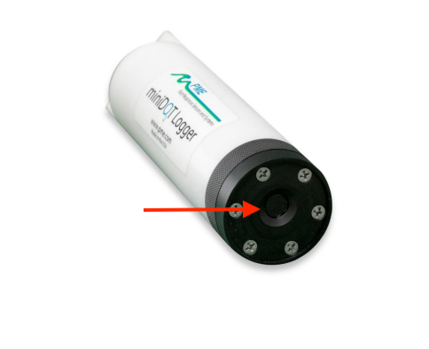
Figure 1. PME miniDOT logger with arrow indicating the sensing ‘foil’ or ‘membrane’

PME miniDOT Logger
Range: 0 - 150% Oxygen Saturation, 0 - 35 ℃

Equipment and supplies needed:
- miniDOT Logger
- 2 AA batteries
- Zip-ties (or another method for fastening to sampling bottle)
- Computer with Java installed
- Micro-USB cable

General Notes:
- Always use the storage cap to protect the sensing foil (Figure 1) when not in use.
- Always install a desiccant pack inside the pressure housing.
- The miniDOT logger should be attached at the midpoint of the water sampler prior to deployment. After the last sampling bout of the day the miniDOT should be removed from the water sampler and storage cap replaced.
- The instrument can record sampling rates of 1 minute - 60 minutes. Suggested recording interval is 1 minute. This is adjusted in the miniDOTControl.jar program.
- Before first usage, install 2 AA batteries in the backside of the miniDOT logger (opposite side of the control switch) when the black end cap is unscrewed from the white pressure housing (Figure 2, Preparation Step 1). The LED light should flash once to indicate that the software is beginning operation once the batteries are installed. Lithium batteries will operate for longer than alkaline, but when used, the voltage is not an indicator of remaining lifetime of the battery.
- **Do not remove the stainless screws beside the black end cap (Figure 2). This will permanently damage the instrument. The batteries can simply be inserted into the battery slots without any modifications to the device needed.
- If the miniDOT hasn’t been used for an extended period of time (> 20 days), soak the instrument in a dark bucket filled with deionized water or fresh water for a minimum of 24 hours with the storage cap removed. The logger does not need to be powered on during this time.
- Between field sampling days, wet a kimwipe, paper towel, or natural sponge with deionized water to place inside the storage cap to keep the sensing foil hydrated.
- If sampling mission intervals are greater than 20 days, the sensing membrane can be stored dry, but should be rehydrated for a minimum of 24 hours before use. Storage cap should still be used.
- If having communication or operation issues with the logger, consult the PME miniDOT manual. If the LED is flashing red continuously, it is often solved by taking out the batteries and then putting them back in.

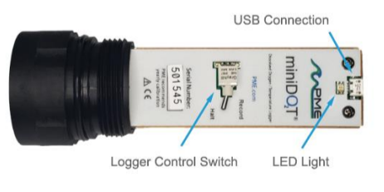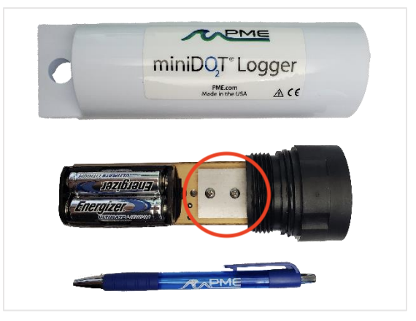
**Do not remove the two screws displayed for any reason. This will permanently damage the sensor.

Figure 2. Upper: miniDOT logger with pressure housing removed showing the logger control switch, micro-USB connection point, and indicator light. Lower: Backside of the logger showing the user replaceable batteries, and the screws that are not to be removed or adjusted.

Preparation Steps:
- Confirm the configuration of the settings for the PME miniDOT. See “Sensor Configuration and Data Transfer from Instruments” sheet.
- When connected to miniDOTControl.jar, the clock on the logger will synchronize with that of the computer. Check that the Q value is reporting greater than 0.7.
- The PME miniDOT should be attached to the Niskin bottle before the Niskin is deployed into the water column. Attach at midpoint with the sensor face pointing along the horizontal plane.
- Ensure that the desiccant pack is installed inside the pressure housing, and that it does not need to be recharged. The desiccant supplied by PME has a colour indicator - if Blue, it is good, but if Pink it needs to be recharged (dry at ~95ºC for a few hours)

Initiate Logging:
- Open the miniDOT logger by unscrewing the white pressure housing from the black end cap. Remove the white pressure housing completely.
- Flip the Logger Control Switch from the “Halt” position to the “Record” position. The LED light will flash green 5 times. The miniDOT logger will now record measurements including time, battery voltage, temperature, dissolved oxygen, and Q. Note that the logger will begin logging immediately when the recording switch is flipped.
- Close the pressure housing. Make sure the desiccant pack is installed and that there is no debris on the o-ring seal or the seat inside the pressure housing before closing the miniDOT logger. Kimwipes should not be used for this as they tend to leave small lint that can interfere with the seal. Screw the white pressure housing back onto the black end cap. Should it become hard to screw or unscrew the pressure housing, a small amount of silicone based o-ring grease can be applied. The miniDOT logger is ready for deployment.
- We recommend leaving the miniDOT in logging mode for the duration of the sampling mission, as opposed to opening and closing the pressure housing in the field multiple times in order to turn the logging off and on. This introduces risk that the o-ring will be compromised by debris.
- Remove the storage cap prior to deployment in the water, and replace it upon recovery

Complete Logging:

- After the final water sampling interval, open the pressure housing and flip the logger control switch back to the “Halt” position. Close the pressure housing if traveling before downloading data to the computer
- Unscrew the pressure housing and connect to the computer with a micro-USB cable. Download raw data from the instrument following “Sensor Configuration and Data Transfer from Instruments” sheet.
- Clean and dry all accessible exterior surfaces except for the sensing foil by rinsing with fresh water and wiping with a cloth if necessary. The sensing foil can be rinsed with deionized water or fresh water and gently wiped with a kimwipe. If more cleaning is necessary consult the PME miniDOT Manual.
- Always store with the storage cap installed

Calibration and Field Adjustment:

- The PME miniDOT is factory calibrated and comes with a certificate of calibration upon arrival.
- Factory calibrations are valid for approximately 1 year but it’s good practice to check the calibration values from time to time. This can be done by ‘Bubble Tests’ and ‘Zero tests’ detailed in the miniDOT manual
- PME has recently released software allowing for a 1-point field calibration adjustment which uses data collected during ‘Bubble Tests’. This software must be downloaded and installed on the logger, but once installed users can compensate for storage drift by performing a ‘Bubble Test’ and applying the adjustment. Factory calibration can always be restored by selecting ‘Select Calibration to Restore’. Details are found in the Field Calibration Adjustment guide.
- By applying field calibration adjustments, time between factory calibrations can be increased significantly.
- PME recommends evaluating the logger performance through bubble tests and zero tests, as well as monitoring the Q value (the ratio of the emission lifetime/emission intensity - description found at https://www.pme.com/product-installs/q-measurement-found-in-minidot). Should the Q value drop below 0.7, PME recommends returning for factory calibration if cleaning and field calibration adjustment do not improve the value.

Bubble and Zero Test of the miniDOT Logger (detailed in the miniDOT and field calibration adjustment manual):

- Obtain a 5 gallon (~19L) black bucket with lid, an aquarium pump and an air stone. Fill the bucket with 4 gallons (~15L) of freshwater or deionized water and let the temperature stabilize. If water temperature is significantly different than air temperature, it will take several hours to come to a stable temperature (changing less than ~0.5deg C/hr)
  - The dark bucket and lid are meant to limit light and inhibit algal growth during the bubble test.
- Enable the miniDOT logger to record at 1 minute intervals. Initiate logging and submerge the miniDOT in the bucket with the black end cap facing upward.
  - The miniDOT black end cap is heavy and will want to flip the end cap towards the bottom of the bucket. Wedge or anchor the miniDOT to ensure the sensing foil is upright and not collecting bubbles on the surface. Bubbles adhered to the foil will cause erroneous readings.
- Turn on the aquarium pump and put the airstone in the bucket near the bottom. Bubbles should be continuously coming out of the airstone. Wait for ~1 hour. Note that if indoors, some buildings can have a different air pressure than outside due to HVAC systems. If this is an issue in your location, consider performing this test in an alternate location, or opening doors and windows such that the room pressure is at equilibrium with the exterior air pressure.
- During the bubble test, obtain an absolute barometric pressure value (mbar) for the elevation at which the test is being performed. If barometric pressure is unknown, the elevation field in the software can be used to estimate based on a mean sea level pressure of 1013.25 mbar.
***If the absolute reading of the pressure sensor of the CTD-Diver has not drifted it can be used for this purpose by logging in the same vicinity, and converting the mH2O reading to mbar (mH2O * 98.0665).
- The ‘Bubble Test’ is complete after approximately 1 hour of bubbling, and with a period near the end where temperature is anticipated to be stable (changing less than 0.5degC/hr)
- Once ‘Bubble test’ is complete:
  - Turn off the aquarium pump and remove the air stone from the bucket.
  - Add 1 tbsp of baker’s yeast and 1 tbsp of sugar to the bucket and stir into solution. The yeast will consume the oxygen in the water as they metabolize, drawing down the dissolved oxygen content to zero in approximately 1 hour. Replace the lid and do not disturb the water during this time. Collect data for at least 1 hour
- Once the ‘Zero Test’ is complete remove the miniDOT from the bucket, rinse thoroughly and dry off the housing.
- End logging and connect to the miniDOT logger using the micro-USB cable and open the miniDOTConcatenate.jar program. Select the folder containing the calibration data.
- Enter in the absolute barometric pressure that best represents when the bubble test was performed and is accurate to the local elevation if not at sea level. If the barometric pressure is unknown, it can be estimated based on elevation or using 1013.25 mbar for mean sea level. The CTD-Diver manual supplies a formula in its Appendix I for estimating the air pressure at a different elevation than where it was measured:
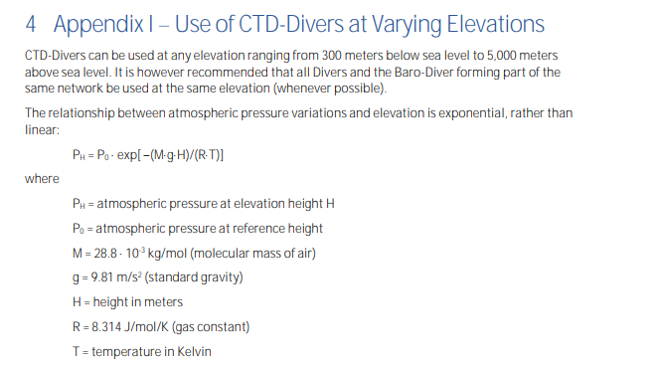

  - Enter a salinity of 0.00 PPT (assumed for freshwater)
  - Select the folder containing the files that were used in the Bubble Test and the Zero Test and concatenate the files. The raw file along with the concatenated file can be placed into a ‘Calibration’ folder on the Host computer.
- The ‘Bubble Test’ data should show close to 100% saturation, and the ‘Zero Test’ data should show <= 0.1mg/L DO. If these parameters are not met, it may indicate the need for a field calibration adjustment, factory calibration, or factory service.

If using the Bubble data to perform a calibration adjustment (at the operator’s discretion):

- After the calibration files have been concatenated, open the miniDOTAdjustCalibration.jar program while connected to the PME miniDOT.
  - From the bubble test concatenated data, select a portion of the % saturation data that best represents the stable temperature and saturation conditions within the bucket. This may be a single point or, more likely, the average of several data points.
  - If the unit has a previous Field Calibration Adjustment, be sure to restore the factory calibration prior to applying the new calibration.
  - Input the selected or averaged % value to then click ‘Adjust Calibration’.
  - The values for the ‘Bubble Test’ should be close to 100% but should be no less than 95% from factory calibration.

